Relative Position and z-Value Solutions
Unusual data values

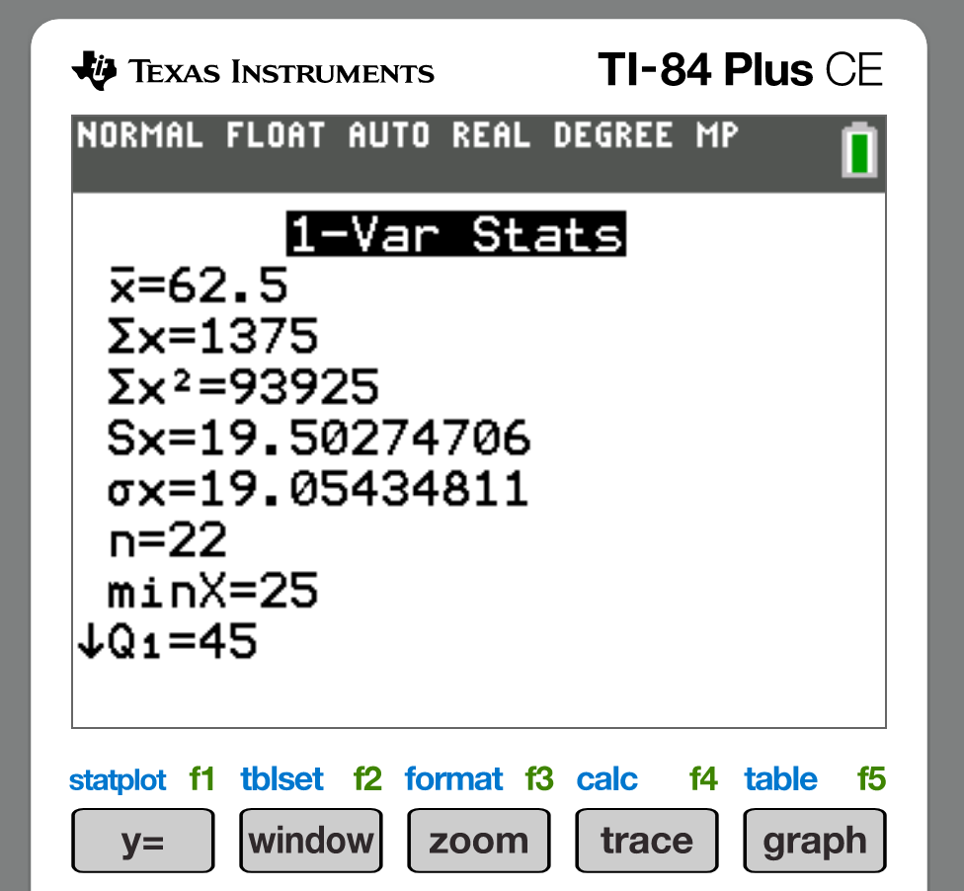

- Mean=62.5
- SD=10.5
- Table
x | z | unusual (Y/N)
40 | -1.15 | N
88 | 1.31 | N
68 | 0.28 | N
25 | -1.92 | N
97 | 1.77 | N
72 | 0.49 | N
85 | 1.15 | N

- z Scale
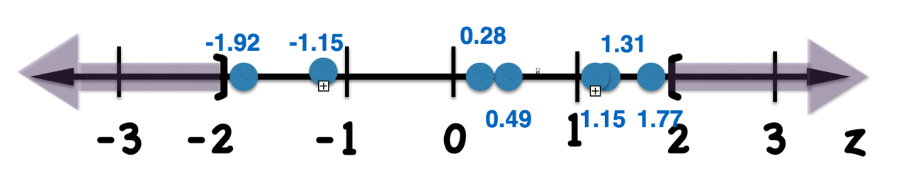
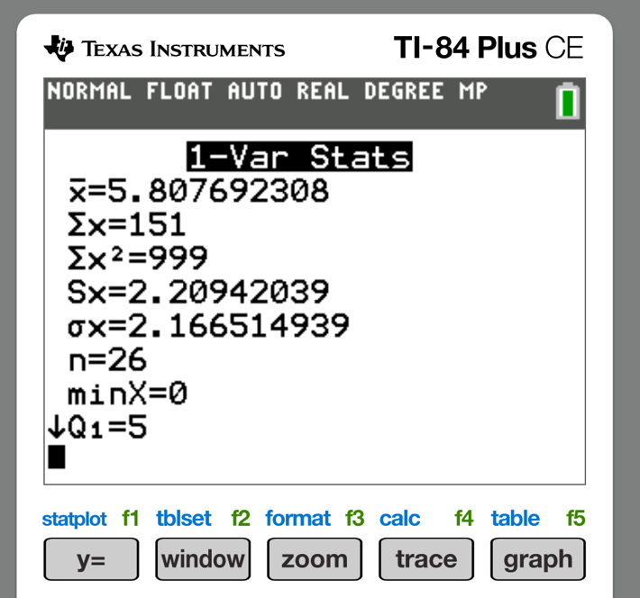

- Mean=5.8
- SD=2.2
- Table
x | z | unusual (Y/N)
6 | 0.09 | N
0 | -2.64 | Y
4 | -0.82 | N
2 | -1.73 | N
7 | 0.55 | N
5 | -0.36 | N
10 | 1.91 | N

- z Scale

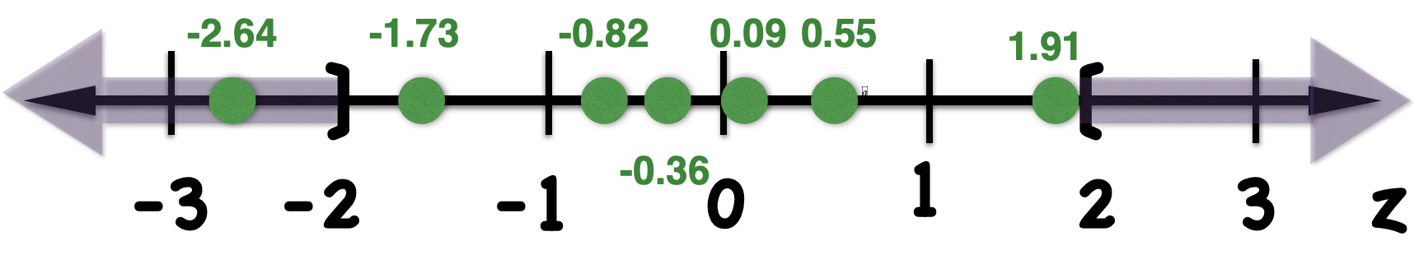

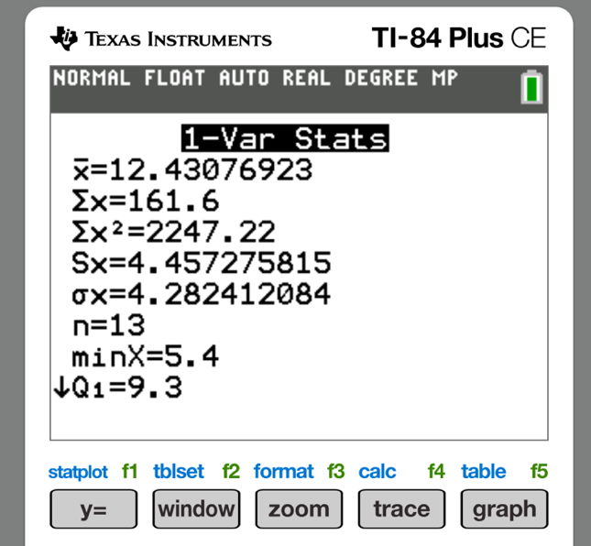

- Mean=12.4
- SD=4.5
- Table
Year | Inches | z | Unusual
2000 | 14.7 | 0.51 | N
2001 | 12.8 | 0.09 | N
2002 | 13.6 | 0.27 | N
2003 | 6.5 | -1.31 | N
2004 | 12.2 | -0.04 | N
2005 | 10.8 | -0.36 | N
2006 | 16.5 | 0.91 | N
2007 | 13.2 | 0.18 | N
2008 | 7.8 | -1.02 | N
2009 | 14.9 | 0.56 | N
2010 | 22.3 | 2.20 | Y
2011 | 5.4 | -1.56 | N
2012 | 10.9 | -0.33 | N

- z -Scale
